詹宗叡

[Dataset]: https://www.kaggle.com/datasets/kasikrit/att-database-of-faces
We used the dataset of AT&T in this project. There are ten different images of each of 40 distinct subjects, 400 images as total. All the files are in PGM format, and the size of each image is 92x112 pixels, with 256 grey levels per pixel.

[Steps]:
preprocess 1
face detection
train
face de-identification
preprocess 2

[Data Preprocess for Blurring and Pixelization]:
- As the images are organized in 40 directories (one for each subject), we moved it out to another directory named “att_img_flat”, and renamed all the images.

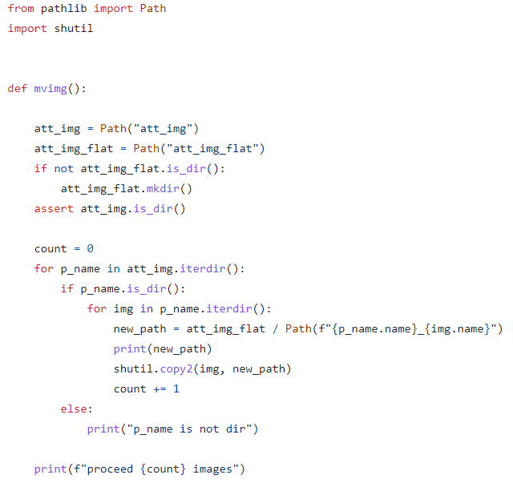

- The second step is to convert .pgm into .jpg files.
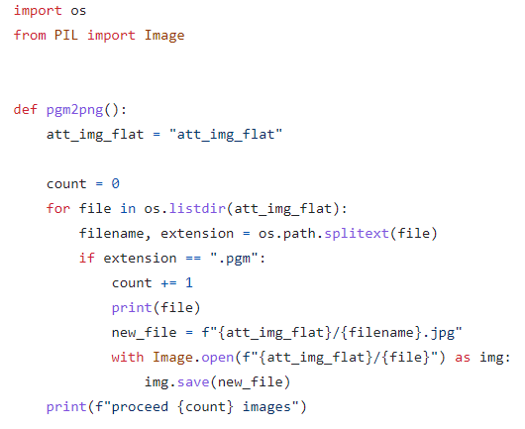

[Face Detection]:
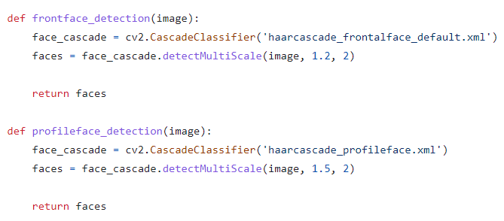
Detect both front face and profile face by using haar-Cascade in OpenCV.

[Face De-identification]:
- Blur
- Parameters: 15, 45, 99
- Set image into the shape of rectangle, and apply Gaussian Blur to it. At last, add the blurred face on the original face to get the final image.
B = 15 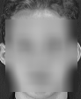
B = 45 
B = 99 

- Pixelate
- Parameters: 4, 8, 16
- Pixelate images by using cv2.INTER_LINEAR and cv2.INTER_NEAREST as the interpolation flag in the cv2.resize() function.
P = 4 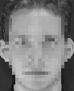
P = 8 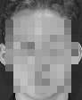
P = 16 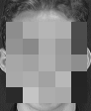

[Split train data and test data]:
- Ratio 8:2
- As there are 10 different images for each person, we choose 2 images as test data randomly, and the rest are train data.

[Neural Network]:
Use CNN as training model, which specializes in image recognition and tasks that involve the processing of pixel data.
- Convolution Layer:
nn.Conv2d()
- Pooling Layer:
MaxPool2d()
- Normalization:
BatchNorm2d()
- Activation Layer:
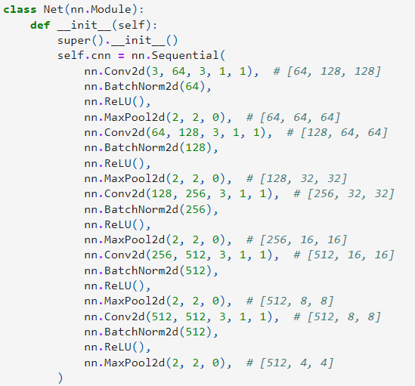
ReLU()

- Fully Connected Layer:
  - Connects neurons in one layer to neurons in another layer.
  - Classify images between different category by training.
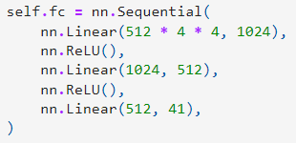

- Output Layer:
  - Contains the label which is in the form of one-hot encoded.
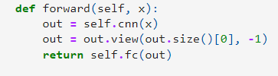

[Training]:
- Batch size = 4
- Epoch = 15
- Patience = 5
  - If no improvement in 5 epochs, then early stop.
- Loss function: cross-entropy
- Optimizer: Adam
  - Learning rate = 0.0003
  - Weight-decay = 1e-5
- Save model with the best performane.
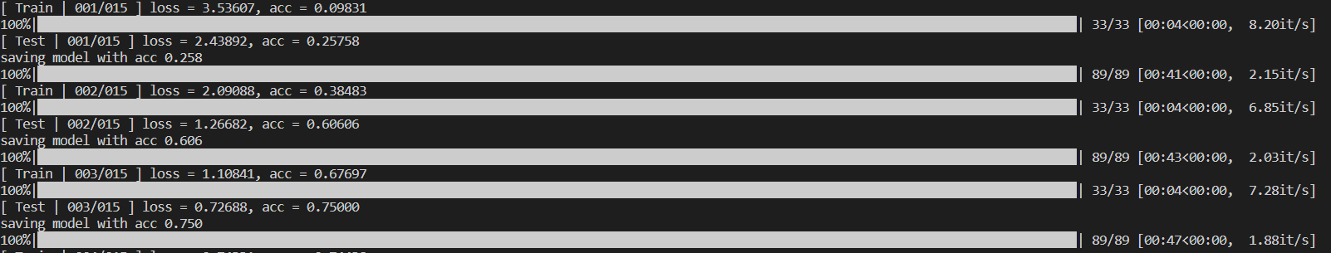
- Print the accuracy and loss in the format of progress bar every epoch.
[Report]:
- Use classification_report in sklearn.metrics to get the score of every class (person).
- The output format of the report is .txt
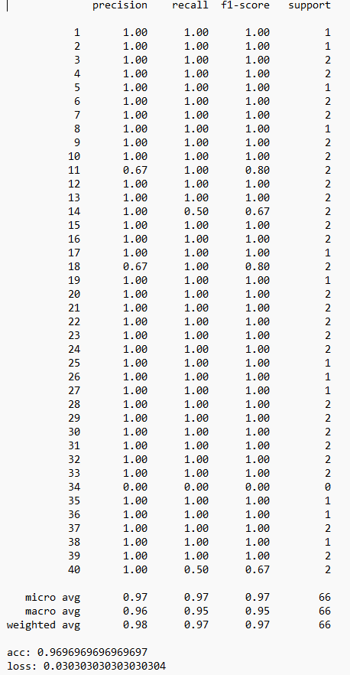

[Result]
- BLUR
param. | accuracy | loss | F1 Score | presicion | support
15 | 1.0 | 0.0 | 1.0 | 1.0 | 71
45 | 0.9865 | 0.0135 | 0.99 | 0.99 | 74
99 | 0.9714 | 0.0286 | 0.96 | 0.97 | 70

- PIXELATE
param. | accuracy | loss | F1 Score | presicion | support
4 | 1.0 | 0.0 | 1.0 | 1.0 | 69
8 | 0.9714 | 0.0286 | 0.97 | 0.98 | 70
16 | 0.9546 | 0.0454 | 0.95 | 0.95 | 66

